ISMAY, Hastings Lionel (known as Pug), British military and first Secretary-General of the North Atlantic Treaty Organization (NATO) 1952-1957, was born 21 June 1887 in Naini Tal, Uttar Pradesh, India, and passed away on 17 December 1965 at Wormington Grange, Broadway, Worcestershire, England. He was the younger son of Sir Stanley Ismay, a member of the viceroy’s Legislative Council and later chief justice of the court in Mysore in the state of Kamataka, India, and Beatrice Ellen Read. On 4 August 1921 he married Laura Kathleen Clegg. They had three daughters.
On 14 January 1947 Ismay was made a Baron, taking the title Baron Ismay, of Wormington in the County of Gloucester. He was the first and last Baron Ismay. His wife was designated Baroness Ismay.

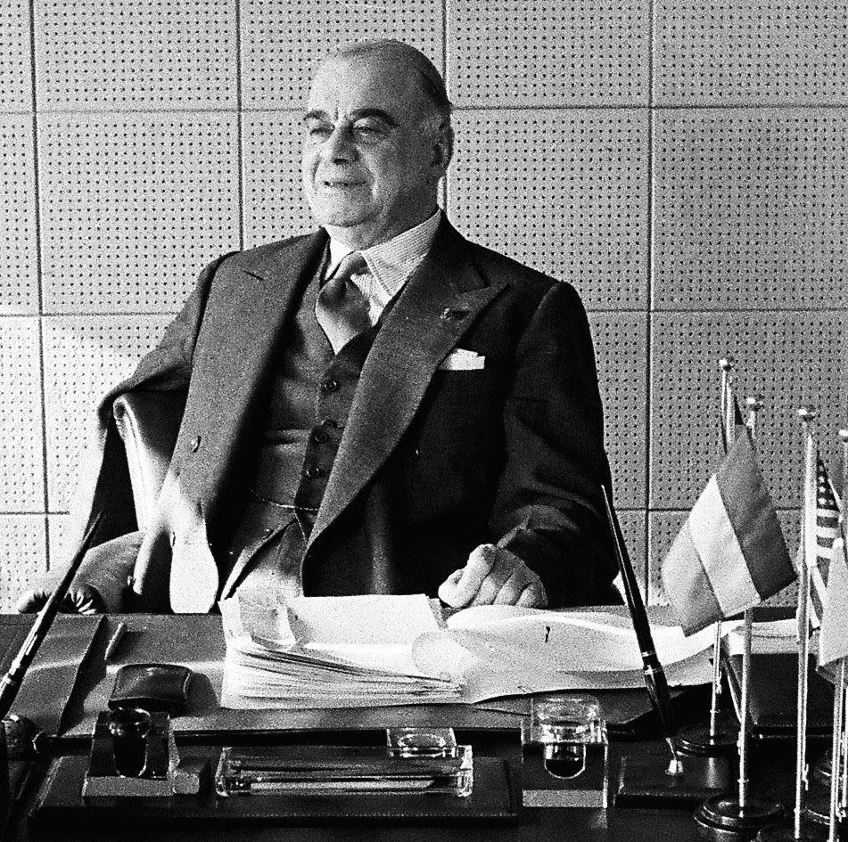
Source: Ismay, 1953, Palais de Chaillot, NATO

Ismay was known throughout his life as Pug because of his heavy, bulldog jaw. He was born in India, where his father served with the Indian Civil Service, which had replaced the East India Company when Britain assumed direct control of India. Having always wanted a military career, he was educated at Charterhouse, a historic boarding school in England, and the Royal Military College Sandhurst. He was first commissioned in the Gloucestershire Regimen in 1905, but two years later served in the 21st Calvary (Frontier Force) in India. He served there until 1914, when he was seconded to the King’s African Rifles. He served during 1917-1919 with the Somaliland Indian contingent and during 1919-1920 with the Camel Corps, for which he was awarded the Distinguished Service Order granted for meritorious or distinguished service by officers of the armed forces during wartime, typically in actual combat. In 1921 he met and soon married Laura Clegg, the only daughter of Henry Gordon Clegg, of Wormington Grange, Worcestershire, during a leave on medical grounds. Their first daughter was born the next year, the other two a few years later. Lewin (2004: 440) calls Ismay an ‘unashamed bon viveur, who also enjoyed racing and polo, tennis, and bridge’. Indeed, Ismay recounts that he devoted ‘more time to polo than to soldiering’ when he was stationed in Rawalpindi (Ismay 1960: 39). In 1921, he passed through the Staff College, at Quetta, India, with distinction. Then, after a period as Deputy Assistant Quartermaster of the Army in India, he served from 1926-1930 as Assistant Secretary of the Committee of Imperial Defence. In 1931, he returned to India as the Military Secretary to Lord Willingdon, Viceroy and Governor-General of India. He came back to London two years later and served in the War Office. From 1936 to 1938 he was Deputy Secretary to the Committee of Imperial Defence under Secretary Maurice Hankey.
On 1 August 1938, Ismay became Secretary of the Committee himself and began planning for possible British war involvement. In May 1940, when Winston Churchill became Prime Minister and Minister of Defence he selected Ismay as his chief staff officer to head a small, carefully selected secretariat. Throughout the Second World War, Ismay was responsible for dealing with Churchill’s draft orders and minutes, the repository of his most secret matters, and had to be ready to depart on short notice on important missions abroad, including almost all of the wartime conferences. He became a lieutenant general in 1942 and full general in 1944. After the war, Ismay remained in the Army for another year, assisting in the reorganization of the Ministry of Defence. In 1945, he was awarded The Order of the Companions of Honour (CH) for service of conspicuous national importance. In 1946, Clement Attlee, the new Prime Minister, thought that Ismay’s services had not been sufficiently recognized and, in 1947, he was made a Baron.
Ismay retired from the Army effective 31 December 1946, but when Lord Louis Mountbatten was appointed Viceroy of India he insisted on having Ismay as his Chief of Staff. From 1948-1951, Ismay worked with Mountbatten, but he did not enjoy this time in India. He did not feel the same attachment to Mountbatten that he had for Churchill and he did not sympathize with the policy of partition. Moreover, he was unsuccessful in persuading the leaders of India and Pakistan not to divide the Indian army immediately and in his call for a referendum in Kashmir over whether it would join India or Pakistan. He declined the grand cross of the Star of India.
When Churchill again became Prime Minister in 1951, be appointed Ismay as Secretary of State for Commonwealth Relations. The same year he was appointed to the Privy Council. Even though Ismay was responsible for Commonwealth relations, Churchill continued to seek his advice on defense matters. Ismay only held this office, which he enjoyed and did not want to relinquish, for six months and then was selected to be the first Secretary-General of the North Atlantic Treaty Organization (NATO), in spite of his age (65), the fact that he was suffering from fibrositis (fibromyalgia) and had been quite public with his belief that NATO was inadequate for the challenges of the Soviet Union. He had characterized NATO as ‘too much harness and too little horse’ (‘Ismay Becomes’ 1952: 3). He also thought of himself as lacking in diplomatic experience and ‘too tired to provide the initiative and original thought which were called for’ (Ismay 1960: 461). However, Ismay’s selection for the newly created position solved a dilemma, as Sir Oliver Franks, British Ambassador to the United States (US) had turned down the position and the Canadian government had refused to make Lester Pearson available. Ismay assumed office on NATO’s third anniversary, 4 April 1952. Although he was not the first person identified for the position, ‘he came to NATO with greater practical experience in administration and government, of the meshing of military and civilian machinery, than any other man on either side of the Atlantic’ (Cook 1989: 255).
As the first NATO Secretary-General, what Ismay did in office significantly shaped the various roles he needed to fill: alliance spokesperson, North Atlantic Council (NAC) vice-chair, initiator of ideas, mediator, conciliator, negotiator, administrator and international diplomat (Jordan 1979: 13-14). He was, for example, responsible for staffing and defining the scope of the Alliance’s various divisions: Political Affairs, Production, Logistics, Economics, Finance, Information, Financial Controller, and Statistics. As a civil servant, who was a product of the British cabinet system, he saw his primary responsibility as developing an effective administrative organization built on the foundation of a genuine international civil service. He is also credited with a number of key organizational achievements, including the completion of 133 airfields, joint production programs, and the building of a petroleum pipeline and other related NATO infrastructure programs, essential to Western European defense. Wingate (1970: 203) suggests that what might have been his ‘greatest personal triumph’ was getting all NATO members to commit to a long-term military build-up, holding the Soviets as far east as possible.
Ismay believed that military authorities should be subordinate to the political authorities. Thus, one of his proudest achievements at NATO was the establishment of procedures by which the military authorities, from the Standing Group down, would coordinate their plans and programs through him to the Council and would operate in every way with the work of the International Staff Secretariat. While the process for effectuating this was not perfected by the time Ismay retired, his relationships with NATO’s military leaders at SHAPE (Supreme Headquarters Allied Powers Europe), and especially the Strategic Allied Commander Europe (SACEUR), were consistently good. The first SACEUR, Dwight David Eisenhower, had been a wartime colleague. Moreover, ‘[p]robably because of Ismay’s own military background, the staff officers of SHAPE headquarters found it easy to do business with him even after Eisenhower left’ (Jordan 1979: 43). Ismay has also been credited with being sure that a US general would replace Eisenhower as the successor SACEUR. At the time, it had not been determined that the SACEUR would always be from the US, as tradition dictates today. But Ismay’s private consultation with all of the ambassadors at NATO ensured that the choice of the Harry S Truman administration, Matthew B. Ridgway, would be approved unanimously when Eisenhower left. Yet, while all of this is true, it must be taken into account that for most of the time Ismay held office, it was the SACEURs who were the dominant leaders in NATO (Hendrickson 2006: 18-19). Jordan (1967: 293) saw Ismay’s greatest contribution as Secretary-General as ‘the creation of an international climate in which political decisions could be taken by the Council with the least friction’. Perhaps most memorably, Ismay is acknowledged as the first person to say that NATO’s purpose was to ‘keep the Russians out, the Americans in, and the Germans down’, a phrase often repeated to explain why NATO was still needed long after the fall of the Berlin Wall (Carpenter 2001: 26).
As Secretary-General, Ismay worked hard to influence world public opinion, but clearly was constrained because he could not engage in the public discussion of policy unless he had a Council mandate, and there was only limited coordination of national foreign policies while he was in office. Ismay also believed that NATO would be well served by having a regular NATO parliamentary meeting at which NATO decisions would be debated by such a quasi-legislative body. Although the debates would obviously focus on issues of defense, Ismay’s vision of NATO was one that included the non-military aspects included in Article II of NATO’s constitutive document, the so-called Canadian article of the Washington Treaty. However, there was very little accomplished in this arena because many other international organizations addressed those issues. Ismay himself singled out the Organization for European Economic Cooperation (OEEC) and the International Labour Organization (ILO) in particular (‘Five Years of N.A.T.O.’ 1954: 3). His vision also included NATO as the venue for allied global planning, something that did not sit well with key member states. Ismay had more success in strengthening NATO’s internal force planning procedures, but dealing with the most challenging of such issues, the finger on the nuclear trigger, was one where he did not get very far. He eschewed pressuring ministers or their governments. Ismay’s method was to present his views quietly prior to Council sessions, and then have a national representative put his proposals on the floor, even though under Council rules he was empowered to do so himself. In speech and action, Ismay always insisted he was the Council’s servant: ‘Thus it will be seen that I am not a political Eisenhower or Ridgway. I cannot speak or issue instructions on my own authority. I can only speak in the name of the Council and on the authority of the Council. It is very right that it should be so’ (Press Statement, 18 October 1952).
Ismay told the Council in May 1955 that he was thinking of retiring, but he received ‘so heartfelt an expression of its desire that he should remain for at least another year, that he consented to do so’ (Jordan 1967: 81). His last days as Secretary-General were consumed with proposed troop cuts, most notably by the British. Ismay had made public his decision to resign by the time the troop cuts were announced and thus he no longer commanded the full authority of his position. Yet, he did speak out, saying that if the British rationale were financial, they should not try to augment that rationale by suggesting that troops could be supplanted by firepower, for that rationale could become contagious. A compromise was eventually worked out, but Ismay was not centrally involved in achieving it. Still Jordan (1967: 80) concludes: ‘It was a sad time at NATO – especially in the International Staff/Secretariat – when Lord Ismay retired’ since they had confidence in and respect for him.
Ismay, of course, did not succeed in all his endeavors as Secretary-General. For example, he wanted NATO to be involved in international affairs outside of the North Atlantic. Thus, in 1956, he sought to address the Greco-Turkish dispute over Cyprus, but both the British and Turks opposed NATO intervention. Accordingly, shortly after his retirement as Secretary-General, he declared that ‘NATO must always have an agreed policy for dealing with … developments outside the NATO area as they occur’ (Lawson 1958: 163), something that did not formally happen until after the NATO bombing of Serbia. He also encouraged the alliance’s major players to consult about tensions in the Middle East prior to the Suez Crisis. But the British and French involvement there was done covertly, without any prior Council discussion. Ismay subsequently emphasized the need for such consultation, resulting in the appointment of ‘the Three Wise Men’ (Lester Pearson, Halvard Lange and Gaetano Martino), whose report called for a strong Secretary-General, one who could formally propose methods to improve consultations within the alliance and who would also oversee all Council meetings. Revealingly, in Suez, Ismay felt betrayed when his personal friend US President Eisenhower criticized the British action. Indeed when the US voted against the British a second time at the United Nations Security Council, Ismay wanted to resign immediately. ‘It did not seem possible for him to serve an international organization in which he had created and maintained unity of purpose, when America, as the dominant partner, was treating Britain as an outcast.’ He was dissuaded from resigning by his wife (Wingate 1970: 209). Hendrickson’s (2006: 18-19) summary judgment on Ismay’s role as Secretary-General can be understood in this context. While he ‘played an important role in creating NATO’s organizational structure, which has had a long-lasting impact on the alliance, it must also be recognized that serious limitations existed on his ability to lead the alliance’.
After his retirement from NATO in May 1957, Queen Elizabeth II invested Ismay as a King of the Garter, Britain’s highest order. Already 70 years old at the time of his retirement and in ill health, Ismay was still appointed to the boards of several corporations, including the Ashanti Goldfields Corporation. He was also able to publish his own memoirs in 1960, having earlier assisted Churchill with writing his six volumes, The Second World War (1948-1953). Interestingly, the major focus in Ismay’s memoirs is on his service in the Second World War, arguing that to go into depth about his NATO years would require an additional volume. In 1963, Ismay was asked to assist Sir Ian Jacob in a review of the organization of the British military. Being ill, he was unable to contribute much to the review. He died at his home in December 1965. Because he had no male heir, his title expired upon his death.

ARCHIVES: Ismay’s papers are housed in the Liddell Hart Center for Military Archives, King’s College, London, www.kcl.ac.uk/lhcma/cats/ismay/is70-01.htm.
PUBLICATIONS: NATO: The First Five Years 1949-1954, Paris 1954, 1956²; The Memoirs of General Lord Ismay, New York 1960.
LITERATURE: ‘Ismay Becomes Atlantic Alliance Secretary; Ceremonies End Organization’s London Stay’ in The New York Times, 5 April 1952, 3; ‘Press Statement by Lord Ismay, Vice-Chairman of the North Atlantic Council and Secretary-General of NATO’, 18 October 1952; ‘Five Years of N.A.T.O.; Conférence donnée par the The Rt. Hon. Lord Ismay, Secretary General of the North Atlantic Treaty Organization’, 20 May 1954; R.C. Lawson, ‘Concerting Policies in the North Atlantic Community’ in International Organization, 12/2, Spring 1958, 163-179; ‘Obituary: Lord Ismay’ in The Times, 18 December 1965; R.S. Jordan, The NATO International Staff/Secretariat 1952-1957: A Study in International Administration, New York 1967; R. Wingate, Lord Ismay: A Biography, London 1970; R.S. Jordan, Political Leadership in NATO: A Study in Multinational Diplomacy, Boulder, CO 1979; D. Cook, Forging the Alliance: NATO, 1945-1950, New York 1989; W. Jackson and Lord Bramall, The Chiefs: The Story of the United Kingdom Chiefs of Staff, London 1992; T.G. Carpenter, ‘NATO’s Search for Relevance’ in S.V. Papacosma, S. Kay and R. Rubin (eds) NATO After Fifty Years, Wilmington 2001, 25-41; R. Lewin, ‘Ismay, Hastings Lionel’ in H.C.G. Matthew and B Harrison (eds) Oxford Dictionary of National Biography, Volume 29, Oxford 2004, 438-440, www.oxforddnb.com.proxy.ubn.ru.nl/view/article/34122?docPos=1; R.C. Hendrickson, Diplomacy and War at NATO: The Secretary General and Military Action after the Cold War, Columbia, MO 2006 (all websites accessed on 29 July 2012).

Michael G. Schechter

Version 29 July 2012

How To Cite This IO BIO Entry?
Michael G. Schechter, ‘Ismay, Hastings Lionel’ in IO BIO, Biographical Dictionary of Secretaries-General of International Organizations, Edited by Bob Reinalda, Kent J. Kille and Jaci L. Eisenberg, www.ru.nl/fm/iobio, Accessed DAY MONTH YEAR

